Arcgis地图服务发布

*使用Arcgis 10.1 Server版本

Arcgis Desktop 10.1(Arcgis engine)

Arcgis Server 10.1

Windows 2008R2 服务器(可虚拟机)(使用VirtualBOx进行安装)

# 安装操作系统

(安装过程略)

# 安装Arcgis Server 10.1

全命图形化下一步安装。(安装过程略)

# 安装Arcgis Desktop 10.1

全命图形化下一步安装。(安装过程略)

安装完成后需要打开ArcCatalog配置Arcgis Server服务

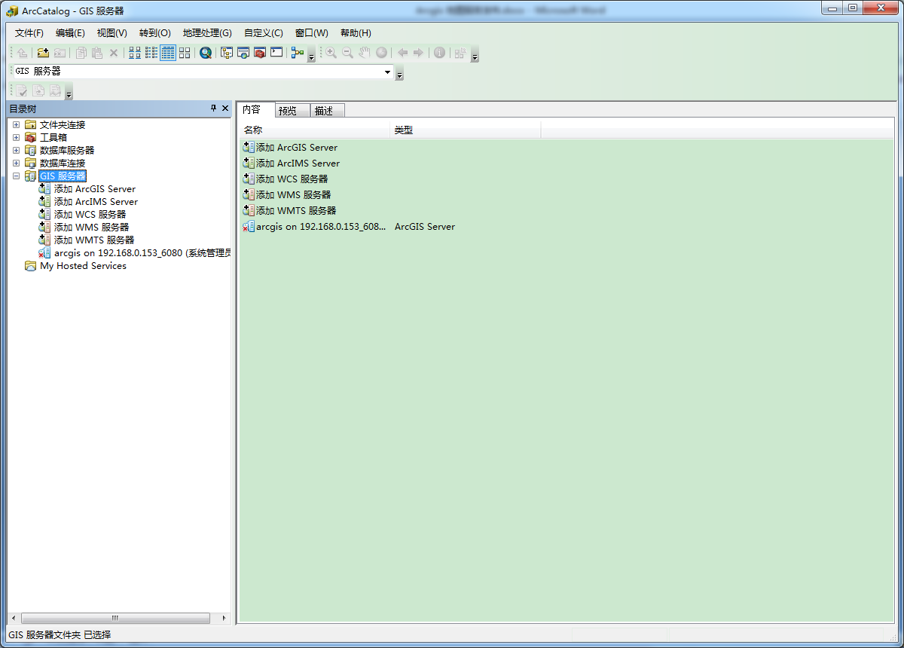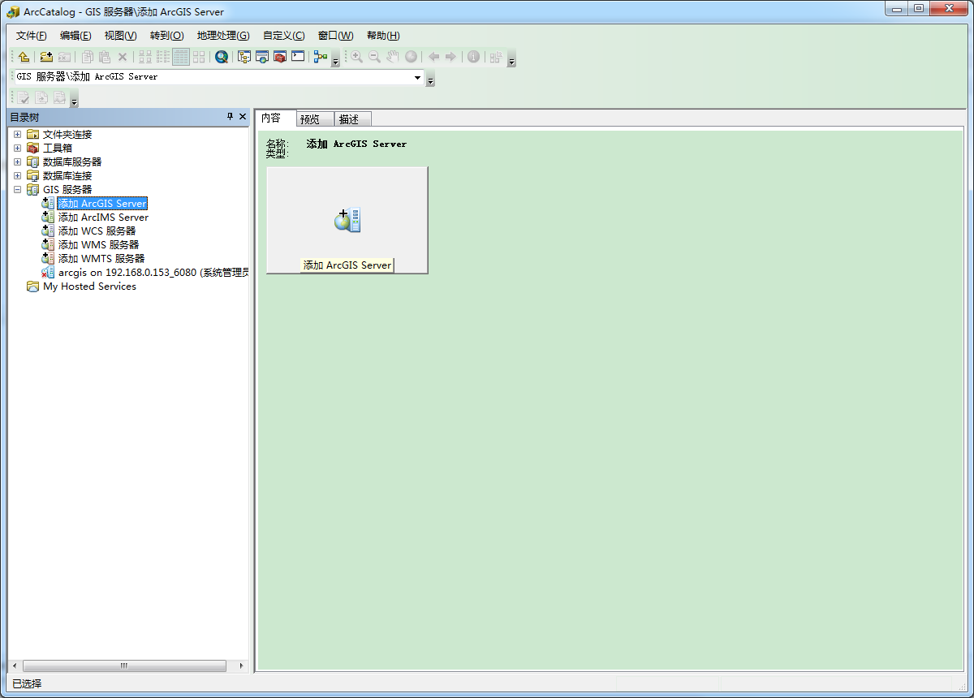

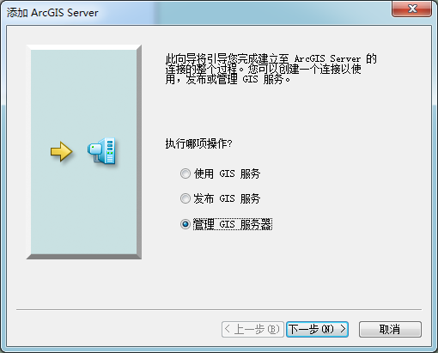

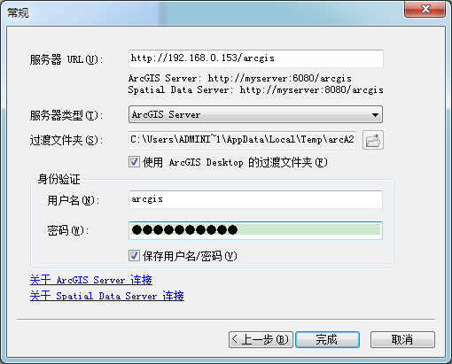

配置完成后再ArcCatalog的GIS服务器列表中将会出现

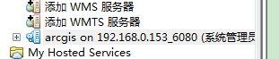

# 发布一个地图服务

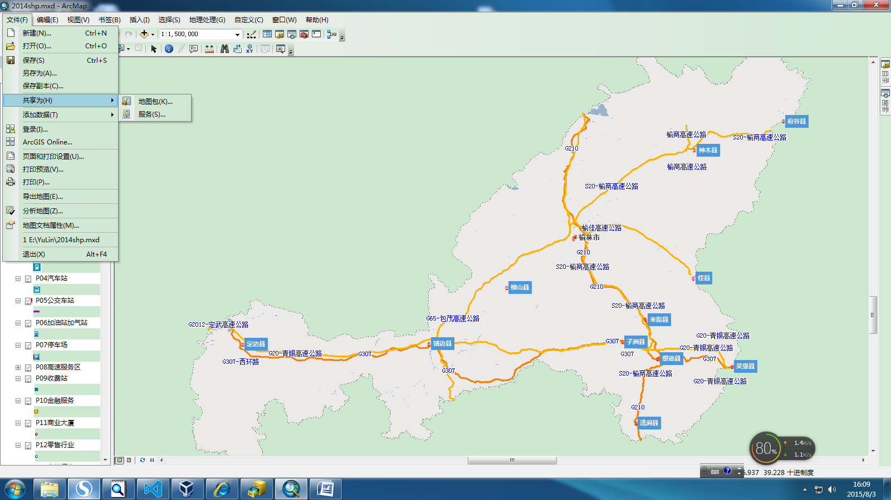

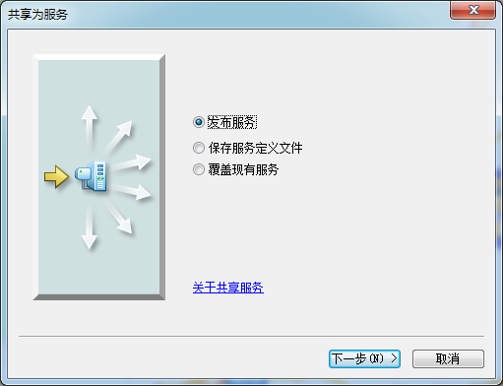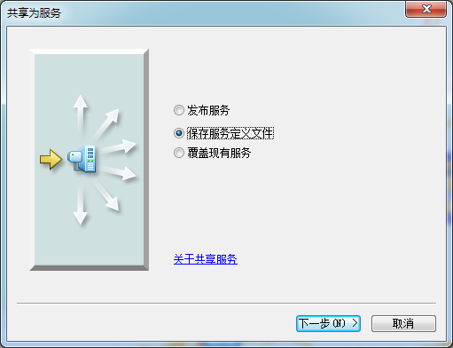

地图服务需要在Arcgis Catalog中配置

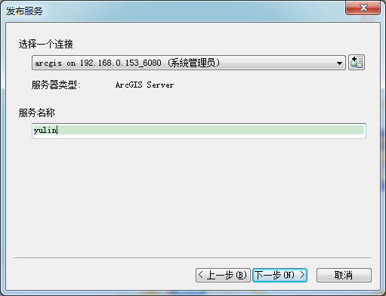

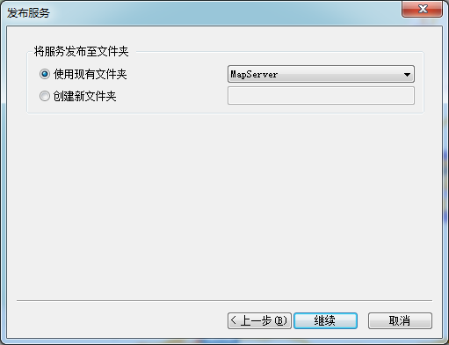

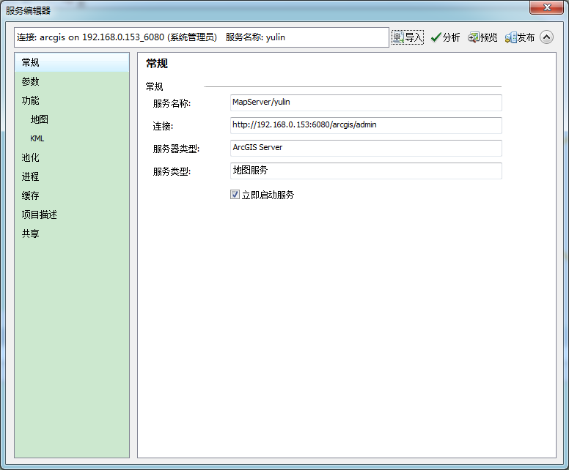

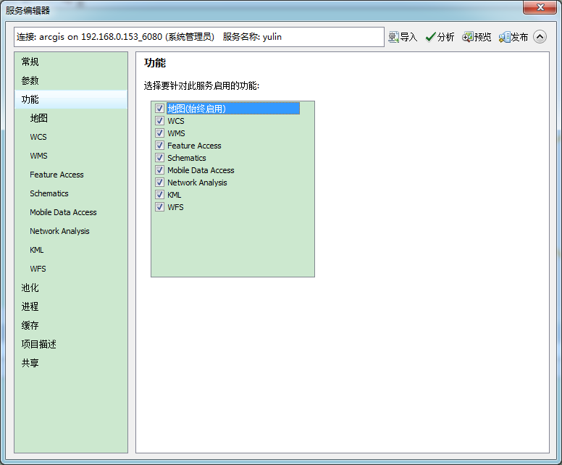

http://192.168.0.153:6080/arcgis/rest/services/MapServer/yulin/MapServer

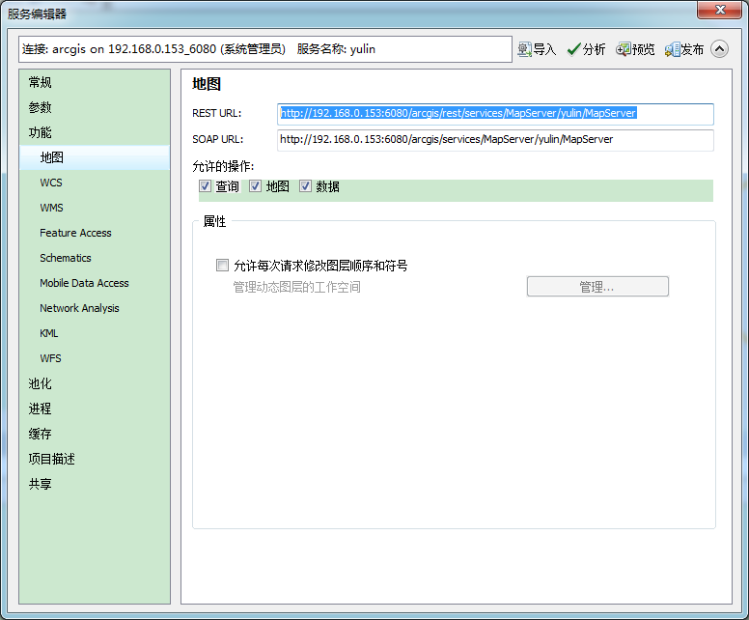

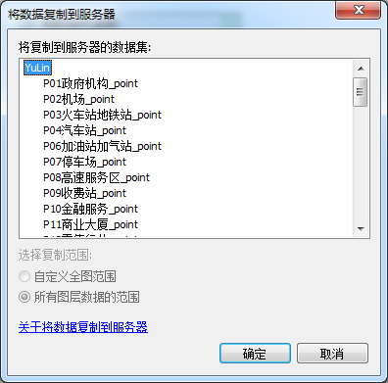

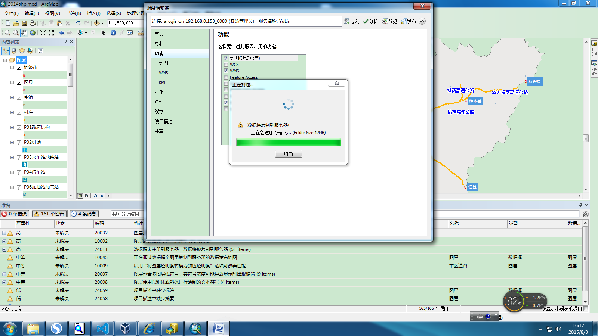

登录ArcgisServer服务

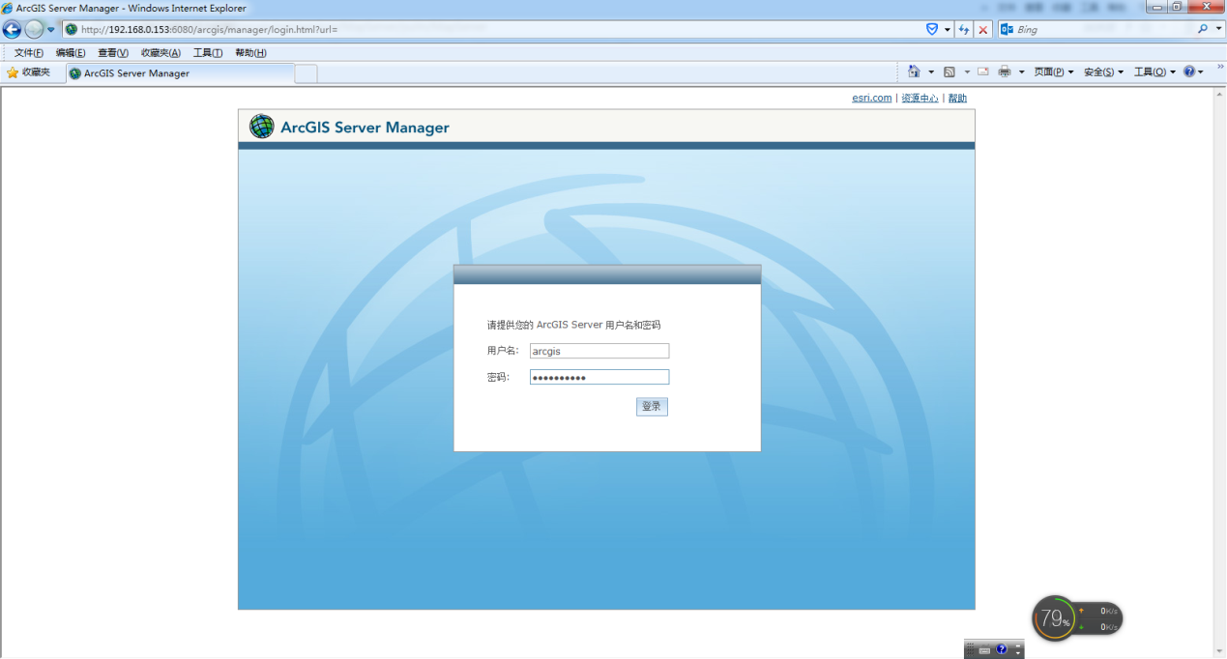

可以在MapServer中查看我们的服务

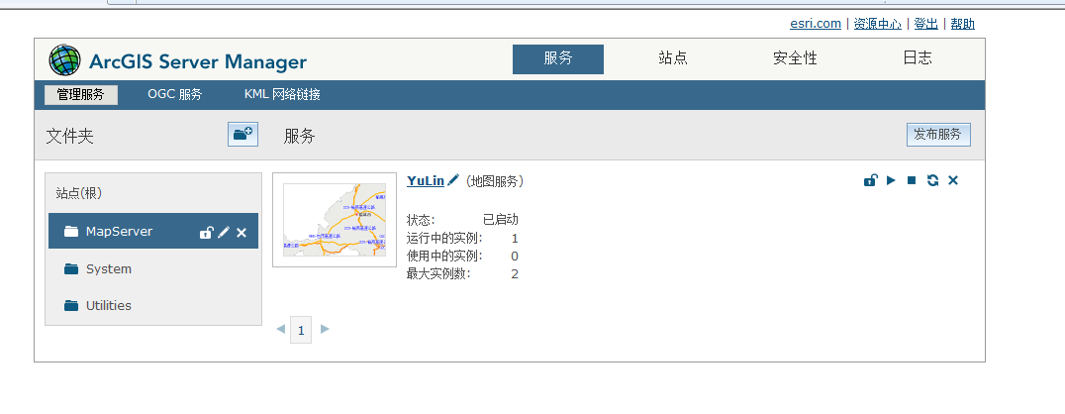

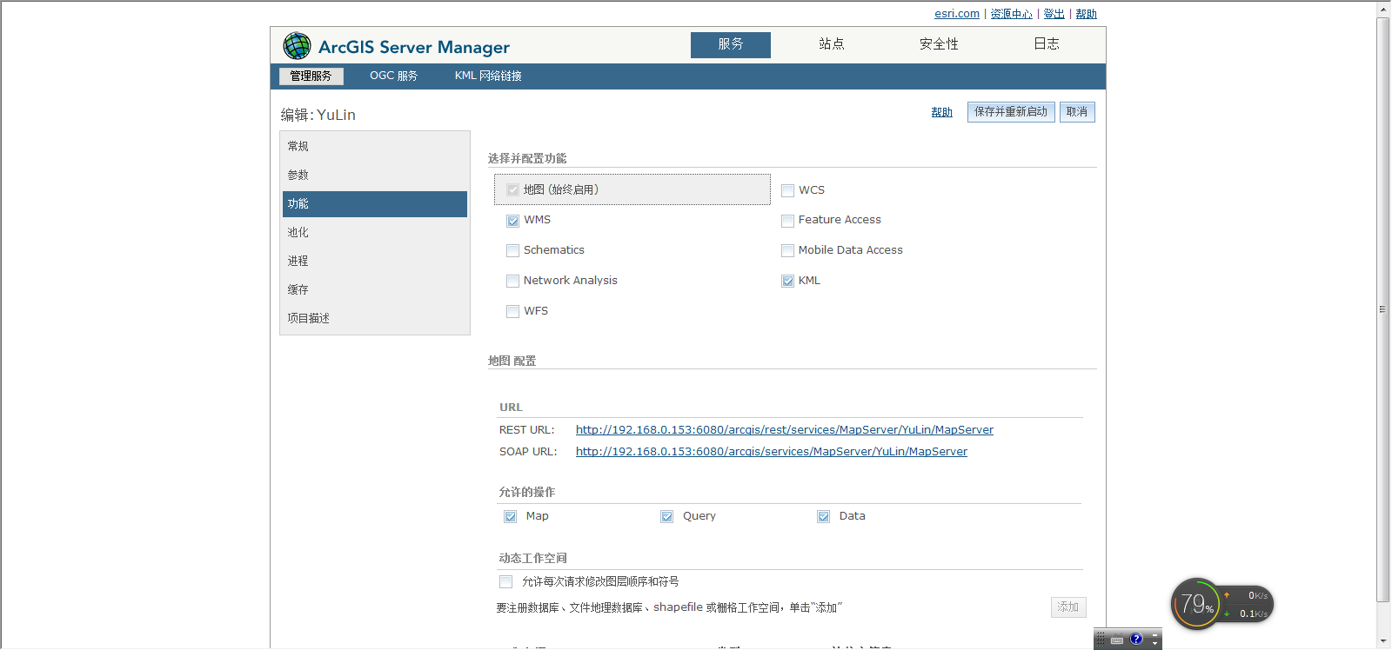

Ie浏览器中打开http://192.168.0.153:6080/arcgis/rest/services/MapServer/YuLin/MapServer

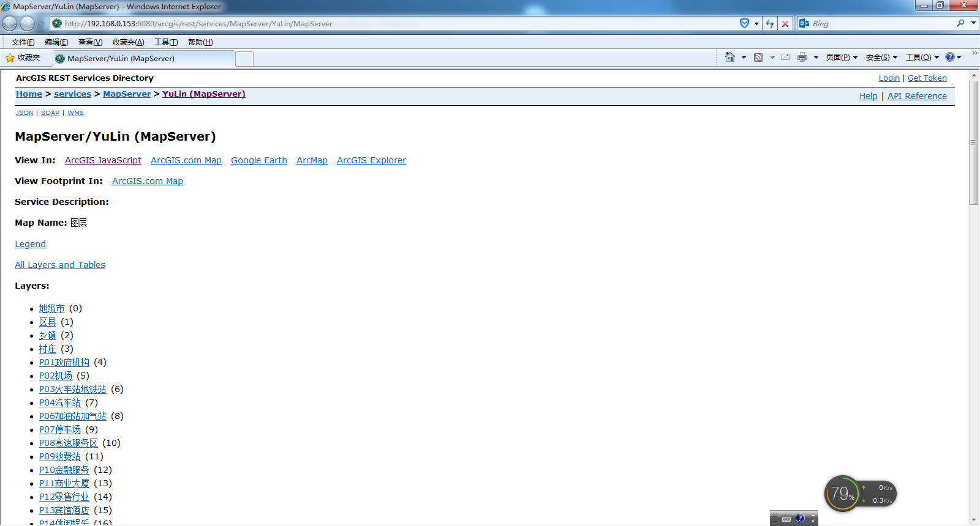

表示服务已经发布成功！现在就可以进行开开发了。

# 调用地图服务并开发

编写基础的代码：

<!DOCTYPE html>

<html>

<head>

<meta http-equiv="Content-Type" content="text/html; charset=utf-8">

<!--The viewport meta tag is used to improve the presentation and behavior of the samples

on iOS devices-->

<meta name="viewport" content="initial-scale=1, maximum-scale=1,user-scalable=no">

<title>Map with scalebar</title>

<link rel="stylesheet" href="http://js.arcgis.com/3.14/dijit/themes/claro/claro.css">

<link rel="stylesheet" href="http://js.arcgis.com/3.14/esri/css/esri.css">

<style>

html, body { height: 100%; width: 100%; margin: 0; padding: 0; }

#map{padding:0;}

</style>

<script src="http://js.arcgis.com/3.14/"></script>

<script>

var map;

require([

"esri/map",

"esri/dijit/Scalebar",

"dojo/parser",

"dijit/layout/BorderContainer",

"dijit/layout/ContentPane",

"dojo/domReady!"

], function(

Map, Scalebar,

parser

) {

parser.parse();

map = new esri.Map("map");

var layer = new esri.layers.ArcGISDynamicMapServiceLayer("http://192.168.0.153:6080/arcgis/rest/services/MapServer/YuLin/MapServer");

map.addLayer(layer);

var location = new esri.geometry.Point(109.18354,38.17994, map.spatialReference)

map.centerAndZoom(location, 8);

//map.centerAndZoom(new ESRI.ArcGIS.Client.Geometry.MapPoint (109.78354,37.87994),1);

var scalebar = new Scalebar({

map: map,

// "dual" displays both miles and kilmometers

// "english" is the default, which displays miles

// use "metric" for kilometers

scalebarUnit: "dual"

});

});

</script>

</head>

<body class="claro">

<div data-dojo-type="dijit/layout/BorderContainer"

data-dojo-props="design:'headline', gutters:false"

style="width: 100%; height: 100%; margin: 0;">

<div id="map"

data-dojo-type="dijit/layout/ContentPane"

data-dojo-props="region:'center'"

style="overflow:hidden;">

</div>

</div>

</body>

</html>

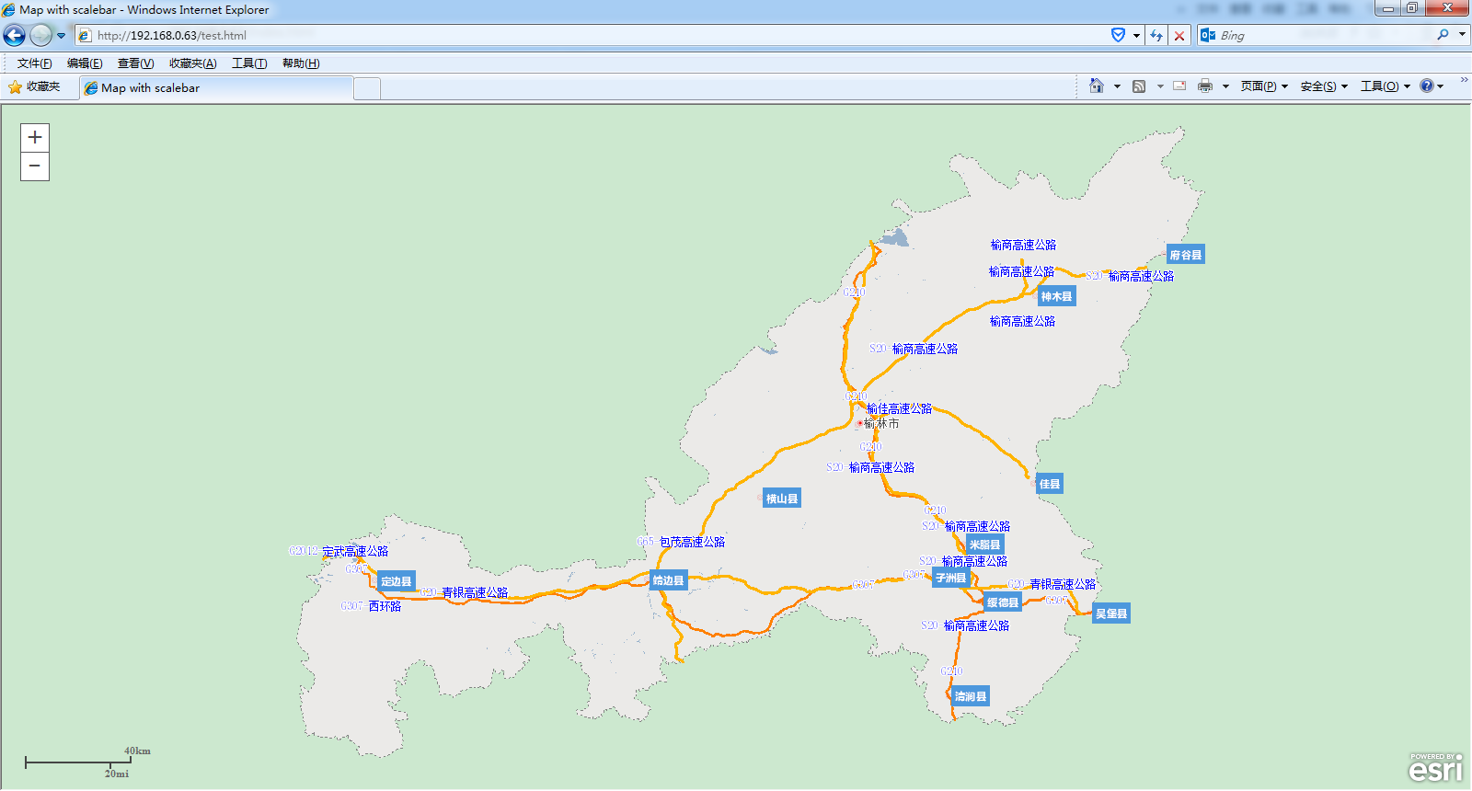

基本的地图服务就发布成功了。

接着就需要学习Arcgis GIS官方网站进行编程了。